**CHAPTER 3**

**PROJECT METHODOLOGY**

This chapter explains the details of the methodology that is used in making and implementing this project. This methodology is used to acquire the objective of the project that will produce a perfect result. To evaluate this project, the methodology based on Iterative and Incremental Development (see Figure 3.1).

**Software Development Method**

Nowadays, software development process is most commonly built around iterative and incremental approach. According to Techopedia website, iterative and incremental development is a discipline for developing systems based on producing deliverables. In incremental development, different parts of the system are developed at various times or rates and are integrated based on their completion. Project work is split into iterations that every iteration includes such phases as requirements analysis, design, implementation and testing. The product is incrementally enhanced with additional functionality in every iteration. In iterative development, teams plan to revisit parts of the system in order to revise and improve them. User feedback is consulted to modify the targets for successive deliverables.

The developers have chosen the iterative and incremental development model to develop the automated system for it suits best the developer’s development process of the project. Thus, iterative and incremental development model helps to reach project goals in the most efficient way.

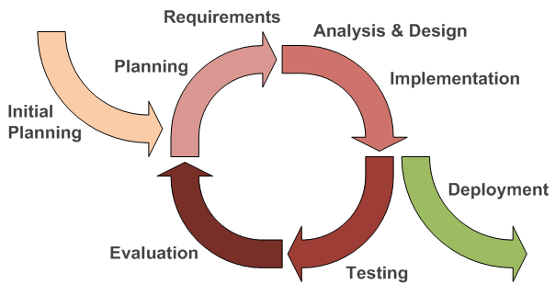

**Figure 3.1. Iterative and Incremental Development**

**3.1 Initial Planning**

In this phase, the developers identified all the information about the system through conducting an interview with the clients to identify their business process. After identifying the process, the developers determined the company’s system requirements and identified the problems encountered while using the manual system.

**3.2 Define Requirements**

In this phase, the developers analyzed all the information gathered and came up with the solution to the problem. The developers established the kind of system that should be developed for the company after studying the company’s business process.

**3.3 Analysis and Design**

In this phase, the developers started creating lay-out, design, module, and prototype that will be needed for the efficiency of the company’s system. The developers created Flow Chart, ERD (Entity-Relation Diagram) to fully understand the flow of the company’s process.

**3.4 Implementation**

In this phase, the developers had already noted the requirements for the improvement of the system. The developers find out that there are problems in the process of the system. Functions were also added to meet the requirements of the system.

**3.5 Testing and Evaluation**

In this phase, the developers are ready for testing the system. The developers gathered all the testing results to identify from the different users of the system and were able to identify if there are any problems found in the system. Evaluation from the users was made after testing the system in line with the system requirements.

**3.6 Deployment**

In this phase, the developers and the client will settle on if the system is ready for deployment or the system will undergo revisions for improvements. If the system is ready for deployment, the developers will present a user manual and conduct training on how to use the system.